Queensland Fruit Fly
Information in Kirundi

Udukoko Tw’inzuki twonona ivyamwa tw’i Queensland
Inzuki zonona ivyamwa z’i Queensland zirateye ikibazo kinini kw’ihinguriro ry’amashurwe ry’i Victoria ryinjiza amamiliaridi y’amadolari ashika $2.4 kandi ugutunganya neza ibijanye n’izo nzuki kugira ngo umwimbu utere uja imbere kuvana n’ukugira uruhara rukomeye rw’abatera amashurwe mu kigo mu turimo duto duto hamwe n’abayarima ku rwego runini kugira ngo bazoyakuremwo amahera menshi.

Inzuki z’i Queensland zironona ivyamwa vy’uburyo butari buke, hamwe n’izindi mboga bigatuma habaho umwimbu muke kandi zigatuma ivyo vyamwa bibora ntibibe bigishoboka kuribwa.
Bimwe mu vyamwa bimenyerewe guterwa hamwe n’imboga biterwa, vyononwa n’izo nzuki harimwo inyanya, peaches, apricots, apples, pears, amapirimu, capsicums, imyelayo, indimu, amacungwa.
Udukoko dutuma haba ivyamwa kenshi na kenshi turondoka tukaba twinshi mu gihe hashushe kubera yuko urugero rw’ubushuhe ruduga kandi rugatuma utwo dukoko turwirirana muri ico gihe mu mwaka kuko amagi aberagurwa mu misi ibiri canke itatu akavyara ibinyagu bito bito
3. Amagi aberagurwa mu misi ibiri gushika kuri itatu akavamwo ibinyagu, bito bito.

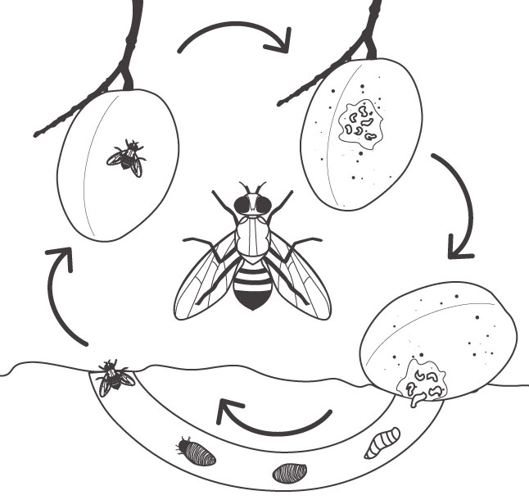
Inzuki z’igitsinagabo zikeneye gufungura emale flies need to feed on protein for ku ma protein kugira ngo zikure
2. inzuki zitera icamwa kugira ngo zitemwo amagi
1. Inzuki zica ziva mw’ivu igihe ubushuhe bwongerekanye bugashika kuri degre zigera kuri 20.
Raba neza: kugabanya agace ka mbere gatuma habaho inzuki ni ko gatuma zitabandanya kurwira.
5. Ivyamwa bica bikorokera hasi aho ibinyagu bishobora kwinjira mw’isi maze bigahinduka inzuki ntonto.

4. Ibinyagu birya ivyokurya bivuye mu camwa mu misi 11-16 & bigatuma ico camwa gica kibora
6. Bivanye n’urugero ubushuhe bw’ivu rigezeko, inzuki zishobora kwaduka mu misi 9, canke igihe ari mu rushana, mu gihe haba hakanye cane bifata igihe kirekire cane, mbere amezi menshi .

Uruyuki rutuma haba ivyamwa rukuze rw’i Queensland ruba rufise hafi milimetero 7 z’uburebure, kandi ziba zisa n’agahama kandi zikagira inzobe kandi zikagira n’ibibarabara bisa n’umuhondo.

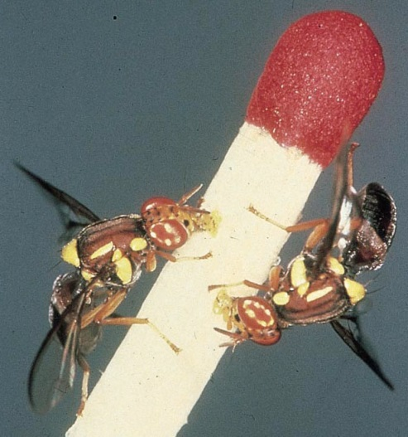

Dukoresheje ubu buhinga bwose tugomba tuvuge aha hepfo bizoduha akaryo keza ko gutera imbere igihe uzoba warimye amashurwe mu karima kawe.

Kuzikumira: Imira inzuki z’i Queensland ntizishobore gushika ku biti no ku biterwa kugira ngo ntizishobore gushikira ivyamwa. Uko vyokorwa bikagenda neza ni ukubuza ko zubaka ivyari vyazo, gazebos, imipfuko kandi ivyo vyose biraboneka ku badandaza bo mu micungararo murimwo hamwe no kubagerageza kubikora.

Kugirira isuku akarima kawe: amura ivyamwa iyo vyeze hamwe n’imboga iyo zeze. Ivyamwa udashaka vyikororerye hasi canke vyaboze bitegerezwa gushirwa mu gisashe bigapfungirwamwo maze bikarekerwamwo imisi iva kuri itanu igashika kuri ndwi ku zuba kugira ngo ivyo binyagu vy’inzuki z’i Queenland bishobore gupfa. Ntuterere ivyamwa bimeze nabi muri irya nyabarega utereramwo ivyo uhejeje guhwata canke imboga zimeze nabi canke ivyamwa vyaboze canke birimwo urunyo mu co ushiramwo umucafu. Gerageza ukureho ibiti vy’ivyamwa utagikeneye kandi utakigirira umwanya wo gukurikirana.

Gusuzuma no gukurikirana ibihe vyose: ivyamwa vyinshi biraterwa, bikononwa n’inzuki z’i Queensland zonona ivyamwa igihe biba bishaka guhishira ni co gituma ugukurikirana no gusuzumwa ari ngombwa kandi ngirakamaro. Ushobora gusuzuma no gukurikirana ivyo mu gukoresha imitego itega inzuki z’igitsinagabo gusa canke mu gusuzuma ivyamwa bimaze kwononekara canke ibitanguye kugira udukomere tw’aho imigera yinjiriye ku rukoba rw’ico camwa.

Gutega izo nzuki: imitego y’inzuki zonona imirima y’ivyamwa vy’i Queensland imbere yuko zonona ivyamwa ishobora kugurirwa mu maduka adandarizwamwo iyo mitego, iyororero hamwe n’ihinguriro ryayo canke mbere ikanagurirwa kuri bwa buhinga ngurukanabumenyi. Gerageza urondere imitego ishobora kwica inzuki z’igitsinagore n’inzuki z’igitsinagabo.

Gukoresha umuti urimwo isumu: imiti yica inzuki z’i Queensland iriho kandi ishobora kugurirwa mu maduka adandaza iyo miti mu micungararo mubamwo canke ku badandaza badandaza ibijanye n’uturima duto duto tw’i muhira cane cane tw’amashurwe n’utwamwa.

Ibindi vyinshi woba ukenye kumenya bariza ngaha kuri ubu buhinga ngurukanabumenyi agriculture.vic.gov.au/qff canke uhamagare ku bashinzwe ku kubarongora mu bijanye n’ivyo kuri izi nomero 136 186.

